

Faculty of Computers and Artificial Intelligence

Computer Science Department

2021/2022

**CS 396 Selected Topics in CS-2**

**Research Project**

Report Submitted for Fulfillment of the Requirements and ILO’s for Selected Topics in CS-2 course for Fall 2021

Team ID No. 8454

|  |  |  |  |
| --- | --- | --- | --- |
|  | ID | Name | Grade |
|  | **201900505** | **عمر حامد عبدالنبي سند** |  |
|  | **201900188** | **انجي محمد عبدالله شعبان** |  |
|  | **201900302** | **رضوي منصور ابراهيم اسماعيل** |  |
|  | **201900183** | **أميمة كمال مصطفى السيد تمراز** |  |
|  | **201900150** | **اسماء محمود عبدالجبار محمود** |  |
|  | **201900397** | **عبدالرحمن ابراهيم عبدالرحمن** |  |
|  | **201900768** | **محمود سعد محمد بكر** |  |
|  | **201900382** | **صلاح بكر فاروق** |  |

Delivered to:

**Dr. Wessam El-Behaidy**

**Eng. Salma Doma**

**Eng. Ahmed Nady**

* **Paper Details**
* Paper Name: Handwritten Text Recognition using Deep Learning with TensorFlow.
* Authors Sri. Yugandhar Manchala & Jayaram Kinthali & Kowshik Kotha & Kanithi Santosh Kumar & Jagilinki Jayalaxmi.
* Publish: 05, May-2020
* Published by: International Journal of Engineering Research & Technology (IJERT)
* Datasets Used: IAM
* Algorithms: In Pre-processing: convert image to grayscale, create image white image with size 128*32 then place the image from dataset in it, then normalize the image.
* Then used 5 CNN layer, 2 RNN layer, CTC, SpellChecker.
* Accuracy: above 90.3%
* **Project Description**

# **Datasets for it**: **SVHN dataset (Street Viewing House Number)**

**Datasets link: https://www.kaggle.com/datasets/quanbk/svhndataset**

Dataset contain:

Training Set 73289

Test Set 26064

Extra Set 531163

**Dimension: 32*32 px;**

## **Class (10 label):**

* Number 1
* Number 2
* Number 3
* Number 4
* Number 5
* Number 6
* Number 7
* Number 6
* Number 8
* Number 9
* Number 10
* **Implementation details**

**Data Pre-processing:**

1. Transpose Data
2. Greyscale
3. Rescale image to 128*32
4. Normalize
5. Split training data to (training and validation) with 25%.

Now we have:

* Training (54942)
* Validation(18315)
* Testing (26032)
* **Our Model**

**13 layers (input, Conv2d, Batch Normalization, Conv2D, Maxpooling, Dropout, Conv2D, BatchNormaliztion, Conv2D, Maxpooling, Conv2d, Batch Normalization, Conv2D, Maxpooling, Dropout, Faltten, 2 Dense layer, Dropout, 2 Dense, 1 Dense Ouptput)**

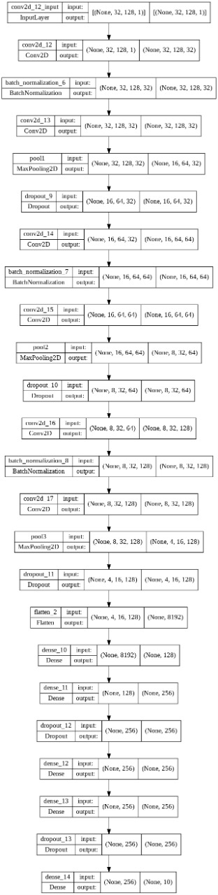

**Hyper parameters**

**Learning Rate: 1e-3**

**BatchSize: 128**

**Epochs:30**

**Kernal_Regulaizer: l2(0.005)**

**Activation Function: Relu, Softmax in last dense layer**

**Optimizer: Adam**

**Total NO of Neurons: 1290**

* **Testing results**

**Loss Curve:**

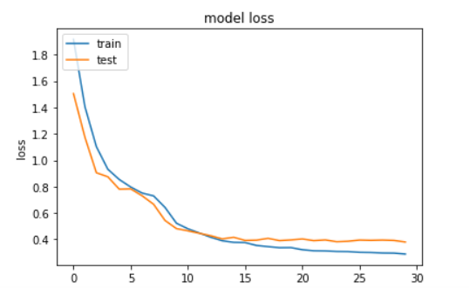

**Accuracy Curve:**

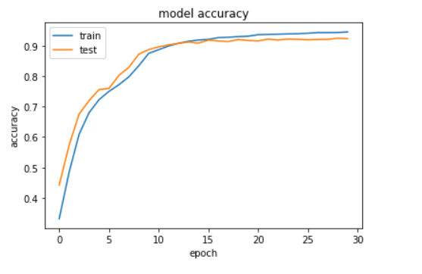

**Accuracy 91%:**

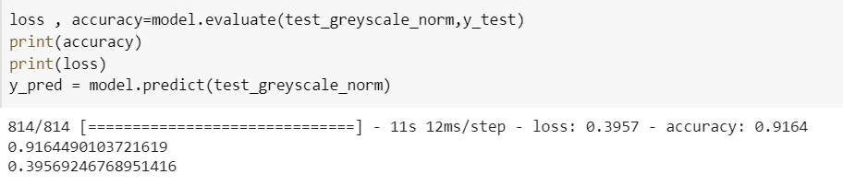

**Confusion Matrix:**

